Em Syth Biography
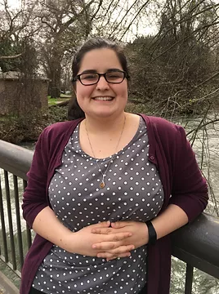
I'm a freelance writer and editor living in Madison, WI. I specialize in medical writing and have experience writing case studies, clinical trial summaries, healthcare IT strategy guides, white papers, mental and behavioral health treatment guides, and burn documentation. I also write adult education on healthcare for CME credits.
I also work as a project management consultant for clients. I have 7 years of experience working in project management and implementation with a strong proven track record of on time and on budget projects, managing complex Electronic Health Record implementations across multi-hospital systems across the United States. I am a big picture thinker, creative problem solver and innovator. I've created new processes and established sustainable frameworks that have changed the way a large company does business. Strong public speaker and demoer.
In my personal life, I have two senior cat roommates. I enjoy walking and hiking. I've also recently started dabbling in digital art, some of which is based on my experiences in the healthcare industry and my own experience as a patient.

